How to export Eagle PCB to gerber files

When you finished your design in Eagle, the last step before sending it off to the fab house is to generate gerber files. Autodesk EAGLE includes a handy computer-aided manufacturing (CAM) processor that allows you to load a CAM file and quickly generate the specific files you need for your design.

**Generating Your Gerber Files (up to v.7, see at the bottom for v.8+)**

**1. Open the CAM Processor**

Open your PCB layout (.brd) file in Eagle, Click the “ **CAM**” button or choose “**File**-> **CAM Processor**”. This will open the CAM Processor tool that is used to generate the files.

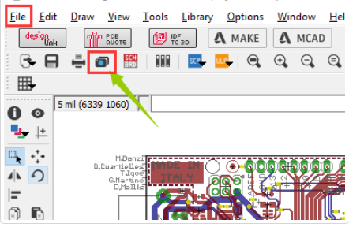

**2.**Select **File**-> **Open** -> **Job**

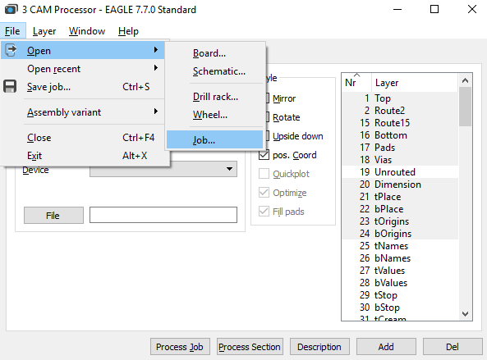

**3.**Then navigate to your default EAGLE cam folder, choose the **gerb274x.cam** file, select **Open**.

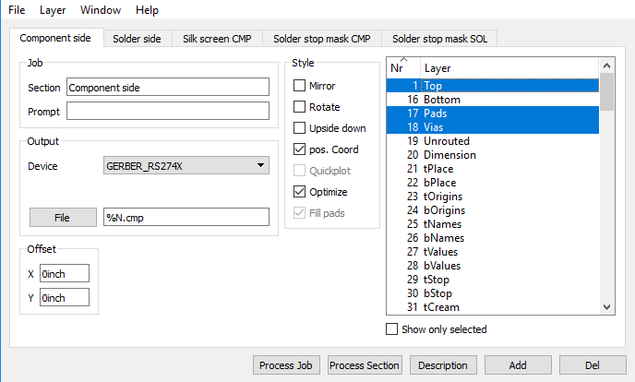

**4. Adding a second silk screen (Optional)**

If you look at the tabs, you will see that you don’t have a file for silk screen bottom. For simple boards, the silk screen is usually on the top layer so that you don’t need the bottom. But if you need silk screen on bottom layer as well, follow these steps:

Click “Add”

Change Section to something like “Silk Screen SOL”

Change File to “%N.pls”

Deselect all layers

Select layers 20 “Dimension”, 22 “bPlace” and 26 “bNames”

**5.** Select the **Process Job**button to create all of your Gerber files. You can find all of your generated Gerber files in the Autodesk EAGLE Control Panel in your project folder.

**Generating Your Drill File**

**1.** Select the **CAM Processor tool** at the top of your interface or select **File** » **CAM Processor** to open the CAM processor dialog.

**2.** You now need to load a drill CAM job to get things started. Select **File**» **Open** » **Job**, and in your default EAGLE cam folder select the **excellon.cam** file, then select**Open**.

**3.** you'll now have a single Generate drill data tab available, which will grab the data from layers **44 Drills** and **45 Holes**, just what you need. Select the **Process Job** button to generate this file.

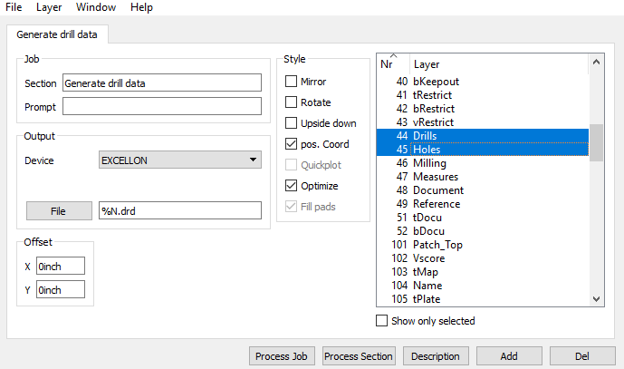

After you have created each gerber file, you should always look at them using a  [Gerber viewer](https://gerber-viewer.easyeda.com/) to make sure everything is ok.

Finally, zip those gerbers up and upload them to [JLCPCB order page](https://jlcpcb.com/order/pcb).

Thank our customer Laurent for recording a video tutorial on how to export gerber files from Eagle 9.1(works with v.8+).  
<https://youtu.be/Jf2y1rTRHDg>

<https://youtu.be/Xg_uh0rsFVg>